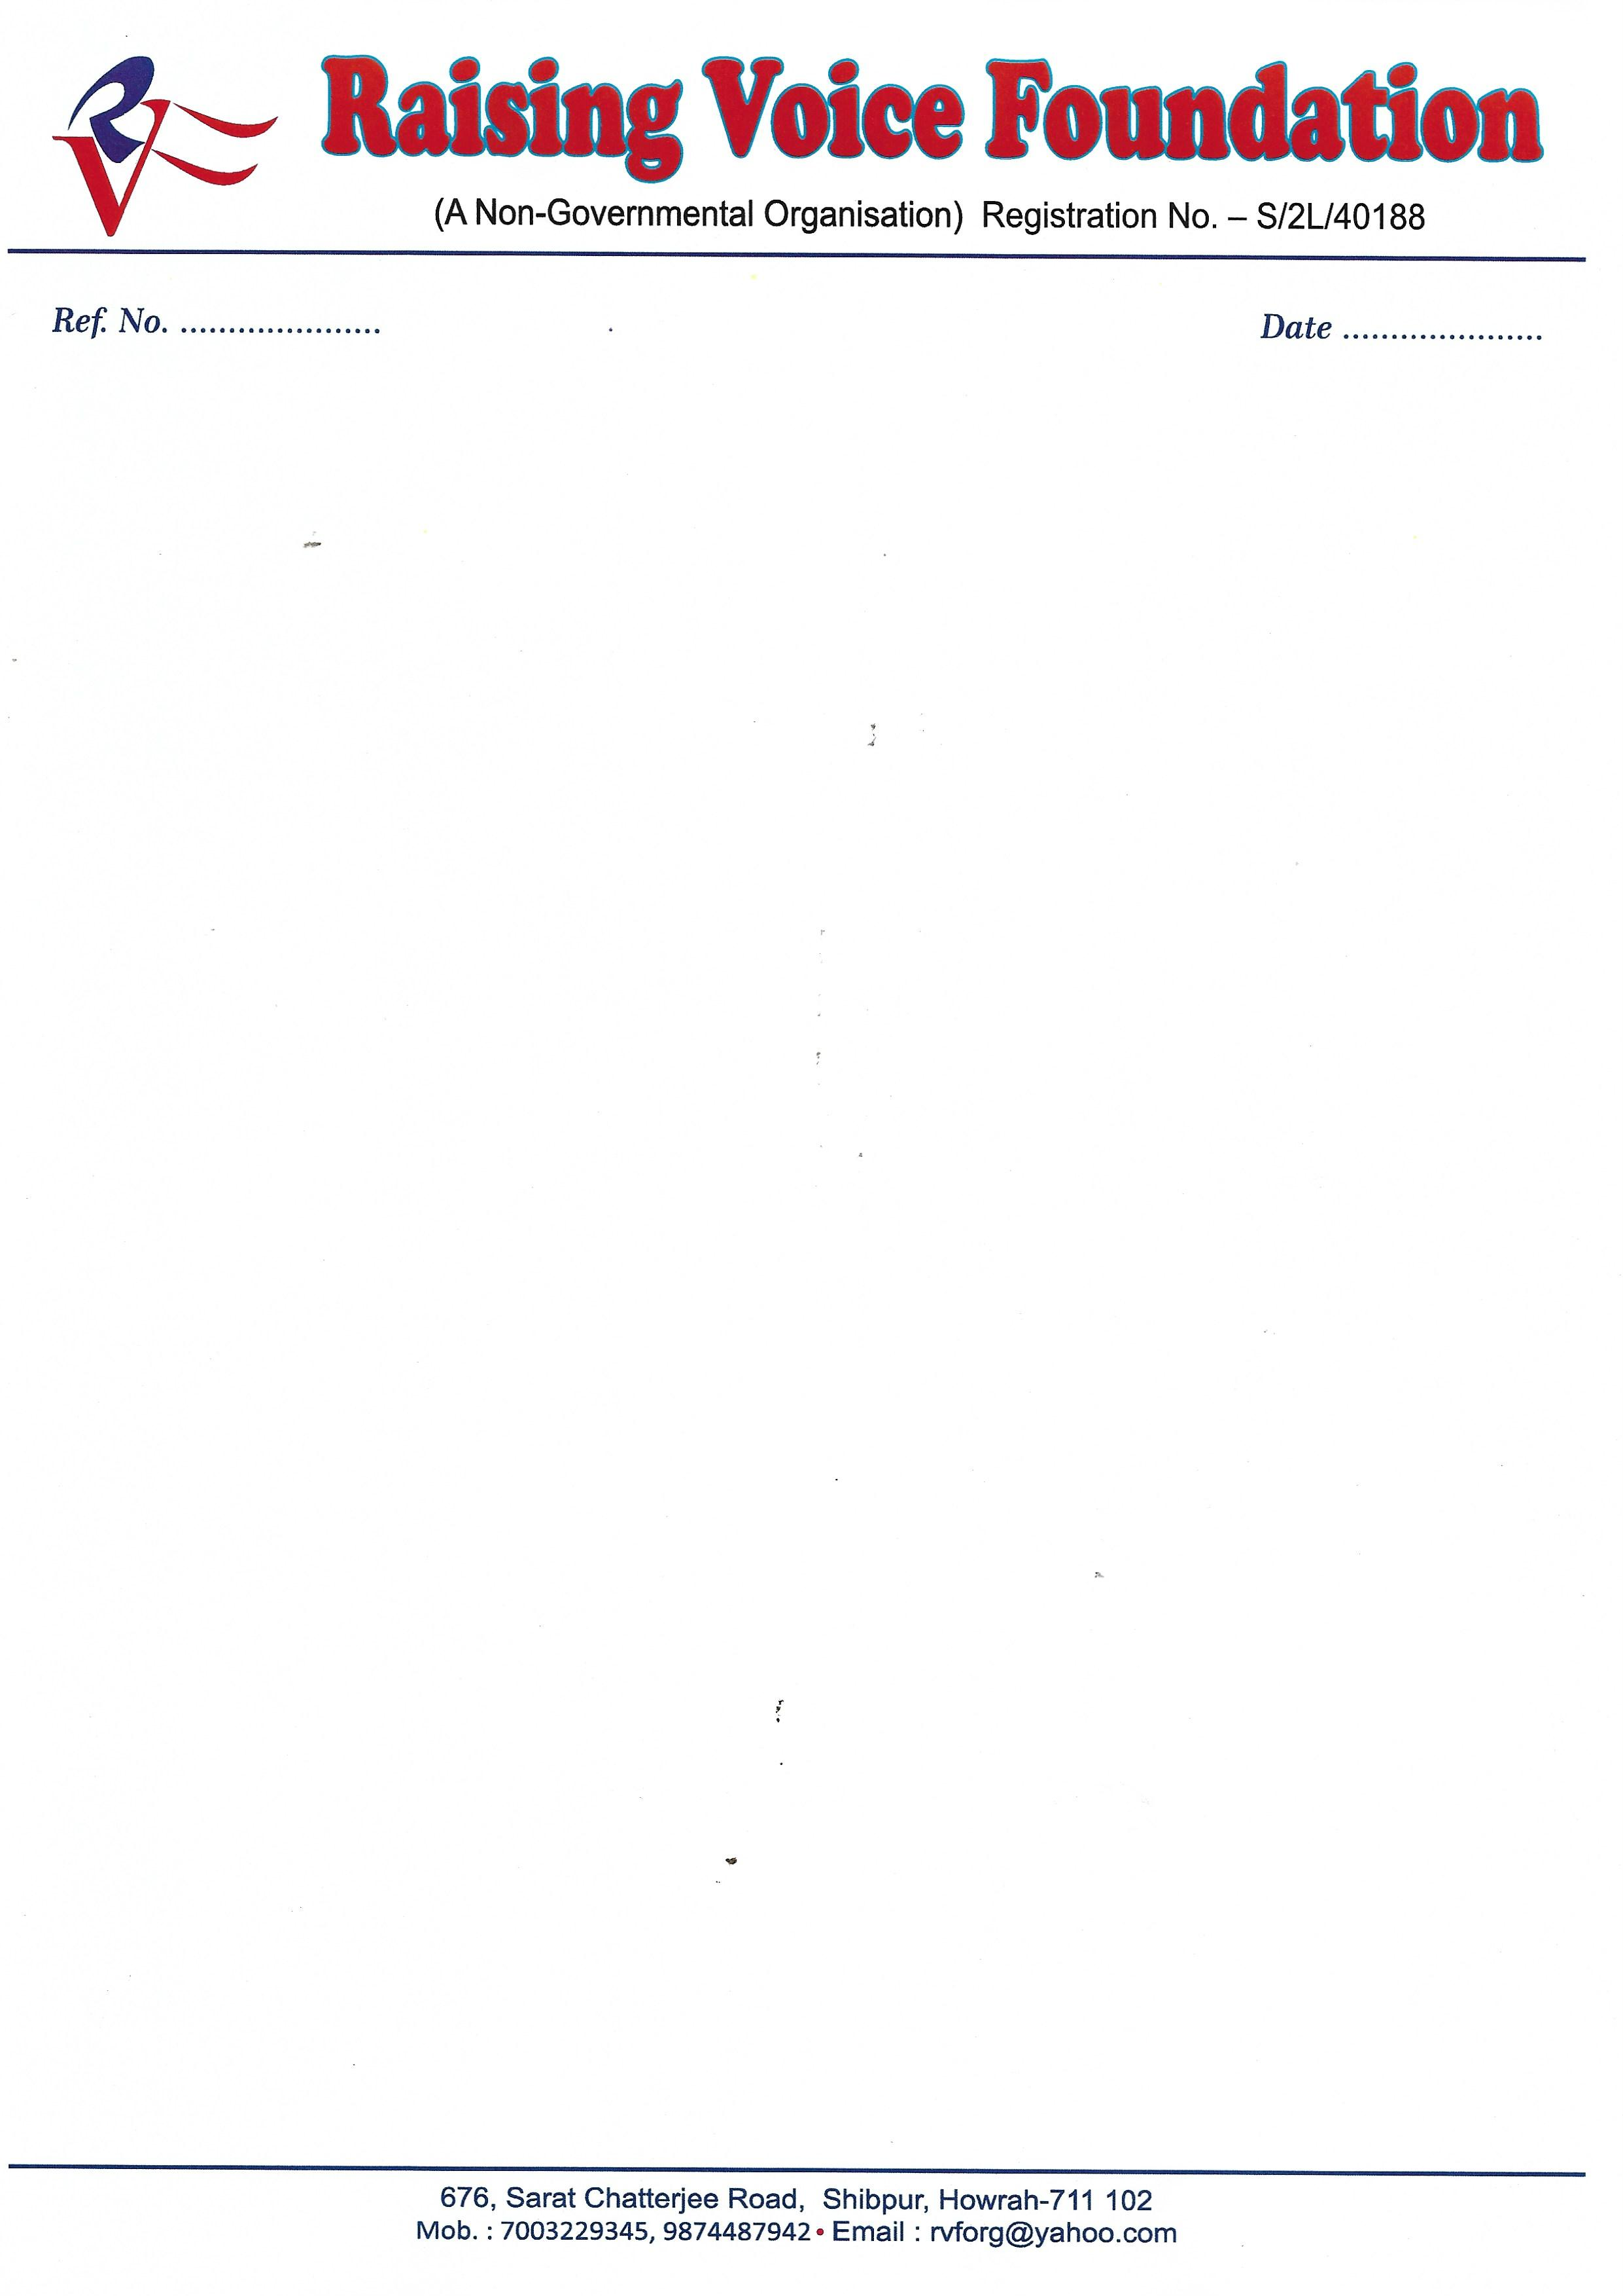

To,

The Secretary.

West Bengal medical self-representative union.

South Howrah Anchalick Committee

Sub:-Request Letter for free medicine for free health check-up.

Respected Sir/Madam.

I Moumita Das , President of RVF situated at 676, Sarat Chatterjee road, Shibpur Howrah:-711102, being registered no S/2L no 40188.Our Organization is working for health issues of backward and unprivileged people .We organise several health awareness camp as well as general health check-up camp.

We are organising a general heath check-up camp on 17.02.2019 from 10am -3 pm in “jagadhatri sewa Samity “situated at tanti para lane, howrah.

I got to know that your organisation provide free medicine so I would like to request you to please provide free medicine. On the above mention date and place to the person who are going to avail the free health check-up on that day. Waiting for your positive reply.

Thanking you

Regards

Moumita Das Sabori Das Dr.Chandan De Hazra

(President ) (Secretary) (Chairman Medial Committee)